CYB 300 Milestone One Worksheet

Andree Salvo
Southern New Hampshire University
CYB 300
Instructor: Jason Keltner

Note: The screenshots in the box are small; you will need to zoom in when reviewing this.
Required Script Element | Bash Script Statement | Screenshot
Change time zone to Pacific/Tahiti Time | - Get-timezone -ListAvailable  - Set-Timezone -name “Pacific Standard Time”  - Get-timezone | 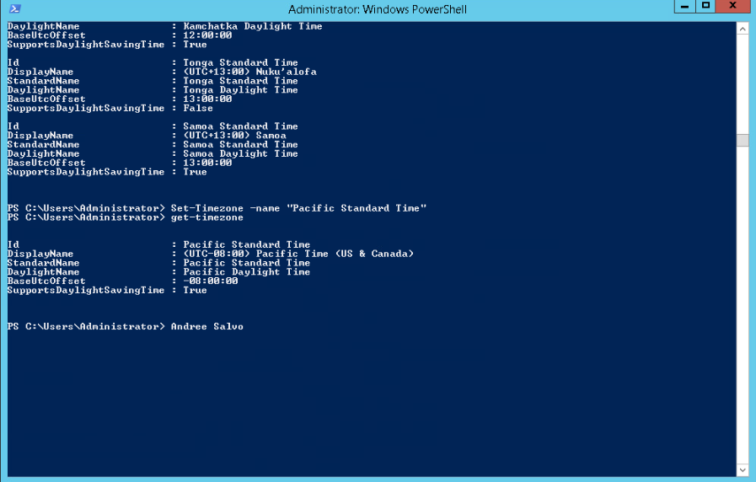
Set date/time to 6:00 a.m. on March 1 of this year | - Get-date -date “2025/03/01 6:00” | 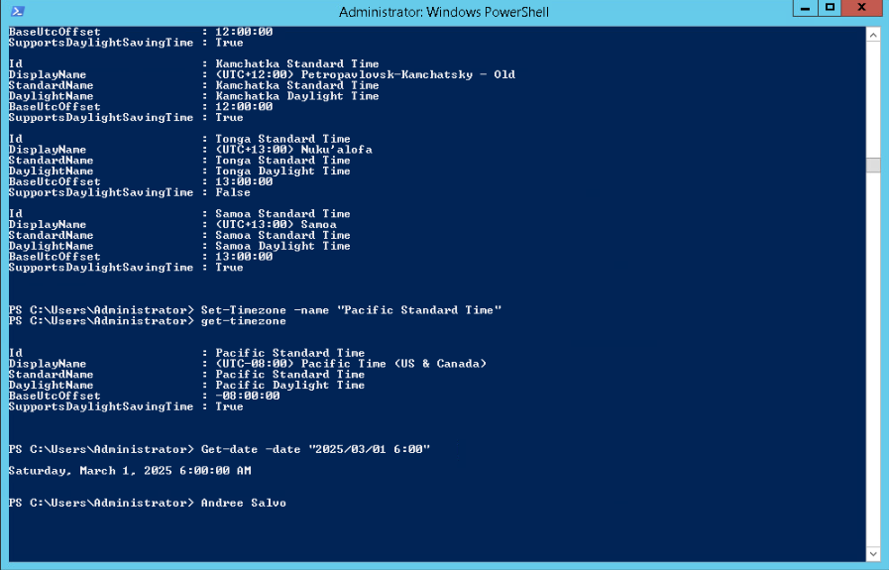
Create a new user group called CYB300 | - New-localgroup -name “CYB300” | 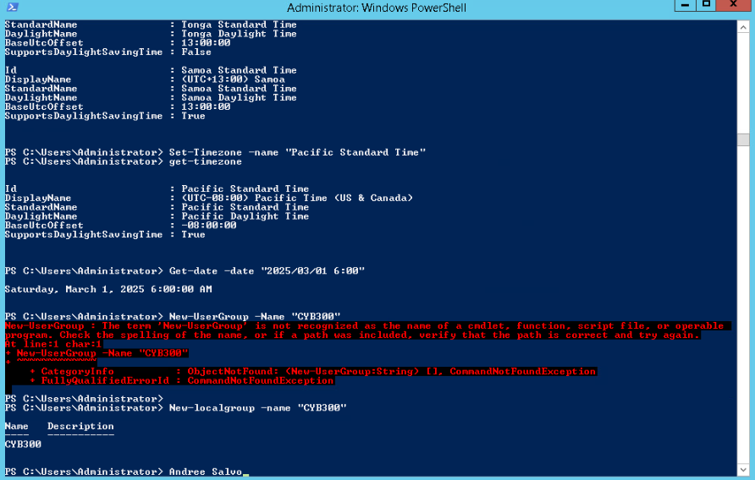
Create a new local user with the following parameters:  - Username: First-Name-Last-Name  - Password: Password123  - Member of CYB300 group | - New-localuser -name “Andree Salvo” -Description “CYB300  - Password: Password123 | 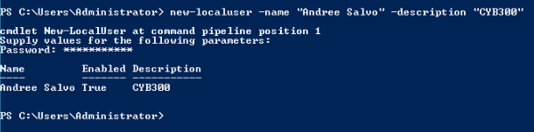
Display a list of running processes beginning with “n” and send them to a text file named “n_Services.txt” | - Get-Service n* >n_Services.txt Notepad ./n_Services.txt | 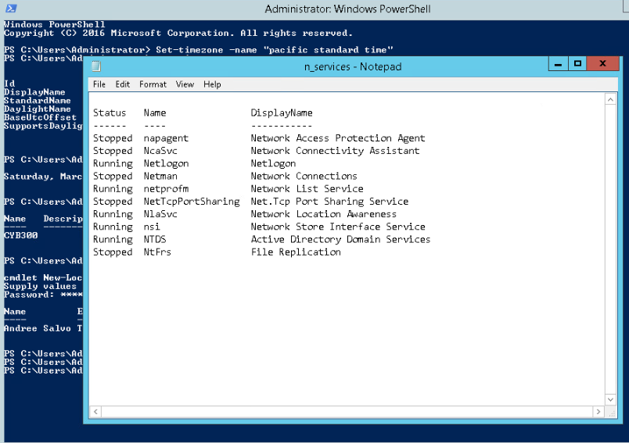
Export Bash history to text file named “CYB_300_History_Firstname_Lastname.txt” | - History > CYB_300_History_Andree_Salvo.txt  - Cat CYB_300_History_Andree_Salvo.txt | 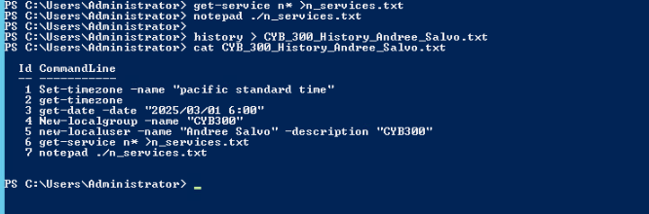
Create a single executable script that contains all the Bash script statements. | #!/bin/bash  sudo timedatectl set-timezone Pacific/Tahiti  timedatectl  sudo date --set="2025-03-01 06:00"  sudo groupadd CYB300  sudo useradd -m -c "CYB300" -G CYB300 "Andree_Salvo"  systemctl list-units --type=service > n_services.txt  cat ~/.bash_history > CYB_300_History_Andree_Salvo.txt | 